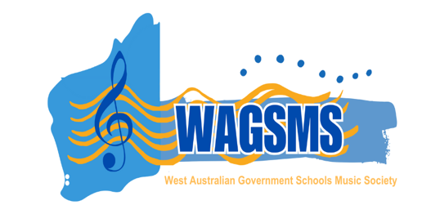

Ticket Information &

Time Schedule 2025

Schools Make Music Concert Series

at Crown theatre Perth

The ticket sale process will be the same fs previous years. Some concerts are sell outs so it is advised to purchase your tickets as soon as possible.

- Tickets are available to purchase via www.ticketmaster.com.au

- The ticket price is $30.00 per ticket. There is no student or pensioner concession on the ticket price. If you are experiencing any financial hardship and aren’t able to afford tickets, please contact your Concert Manager.

- Tickets will be on sale until the show opens. However, most sell out prior to the show.

TIMELINE

Feb/March 2025 | Applications called for WAGSMS Concerts
May 2025 | Closing Date for Concert Registrations
May 2025 | Schools notified of Concert date and Concert Manager
Term 2 | Tickets go on sale for Crown Theatre - Perth
1st June | Deadline for School Item Detail Sheets to be received by Concert Manager

2025 CONCERT DATES

Perth Crown: Monday 23rd June August – Thursday 26th June August 2025

MANPAC: Tuesday 26th August – Friday 29th August 2025

